Text Analytics and Sentiment Analysis Report

Consumer Complaint Database Analysis

Student Information
Student Name: Mpho Tlokotsi
Module: PDAN8411 – Programming for Data Analytics
Dataset: CFPB Consumer Complaint Database
Sample Size: 30,000 Records

Executive Summary
The purpose of this study was to identify the main areas of concern raised by customers and determine overall customer sentiment using text analytics techniques. A sample of 30,000 consumer complaints was extracted from the CFPB Consumer Complaint Database.
The analysis involved data cleaning, exploratory data analysis (EDA), topic modelling using Latent Dirichlet Allocation (LDA), and sentiment classification using machine learning models (Blei, Ng and Jordan, 2003; Jurafsky and Martin, 2023).The findings provide insight into the issues customers experience most frequently and the sentiment associated with these experiences.
The results show that negative sentiment dominates customer complaints, with credit reporting, debt collection, fraud, account management, and loan servicing emerging as the primary areas of concern. Logistic Regression produced the strongest sentiment classification performance and was selected as the final model.

1. Dataset Selection and Justification

1.1 Dataset Chosen
The dataset selected for this project was the CFPB Consumer Complaint Database.
This dataset contains consumer complaints submitted regarding financial products and services. Each complaint includes a narrative description written by the customer explaining their experience.

1.2 Suitability
The dataset was selected because it closely matches the client's requirements. The client wishes to:
- Identify major customer concerns.
- Determine overall customer sentiment.
- Analyse large volumes of textual customer feedback.
The complaint narratives provide rich unstructured text suitable for sentiment analysis and topic modelling, both of which are commonly used to extract insights from large collections of customer feedback (Liu, 2012; Aggarwal and Zhai, 2012).

1.3 Data Quality
The dataset was considered high quality because:
- It is publicly available from a government source.
- It contains thousands of real customer complaints.
- The data is regularly updated and maintained.
- The narratives provide sufficient detail for text mining and machine learning.
A sample of 30,000 records was used to reduce processing requirements while maintaining a large and representative dataset. High-quality data is essential for developing reliable machine learning models and improving predictive performance (Provost and Fawcett, 2013).

2. Model Selection and Justification
The client requires two different analytical outcomes.

2.1 Identifying Areas of Concern
To identify broad complaint categories, Latent Dirichlet Allocation (LDA) topic modelling was used, as it is one of the most widely adopted probabilistic topic modelling techniques for discovering hidden themes in text collections (Blei, Ng and Jordan, 2003).LDA was selected because:
- It is an unsupervised learning technique.
- It automatically identifies hidden themes within large collections of text.
- It does not require pre-labelled data.

2.2 Sentiment Classification
Two supervised machine learning models were used:

Logistic Regression
Selected because:
- It performs well on text classification problems.
- It is efficient and interpretable.
- It works effectively with TF-IDF features.
To identify broad complaint categories, Latent Dirichlet Allocation (LDA) topic modelling was used, as it is one of the most widely adopted probabilistic topic modelling techniques for discovering hidden themes in text collections (Blei, Ng and Jordan, 2003).

Multinomial Naive Bayes
Selected because:
- It is commonly used for text analytics.
- It is computationally efficient.
- It provides a strong baseline for comparison.

Multinomial Naive Bayes remains one of the most commonly used baseline algorithms in text mining because of its computational efficiency and strong performance on document classification tasks (Manning, Raghavan and Schütze, 2008).

3. Analysis Plan
Stage | Objective
Data Loading | Import and inspect dataset
EDA | Understand structure, quality, and distributions
Data Cleaning | Prepare text for modelling
Feature Engineering | Convert text into numerical features
Topic Modelling | Identify broad complaint themes
Sentiment Labelling | Create sentiment categories
Model Training | Train sentiment classification models
Evaluation | Measure model performance
Reporting | Present findings and recommendations

4. Exploratory Data Analysis (EDA)

4.1 Dataset Overview
The dataset consisted of 30,000 records and 8 variables.
Important variables included:
- Date Received
- Product
- Consumer Complaint Narrative
- Company Response to Consumer
- Complaint ID
- Submitted Via
- State
- Timely Response
The complaint narrative was the primary variable used for text analysis.
The dataset shape was:
30,000 rows × 8 columns

4.2 Missing Values
Missing value analysis revealed significant missing values within the complaint narrative field.
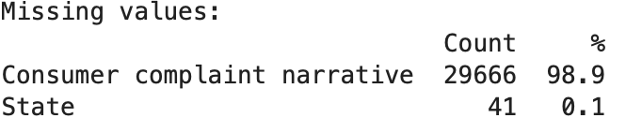
Although the narrative field had many missing values, the remaining records still provided sufficient textual information for analysis.

4.3 Duplicate Records
Duplicate analysis showed:
Duplicate Records Found: 0
This indicates good data quality and no duplicate complaint entries within the sampled dataset.

4.4 Complaint Narrative Availability
Narrative availability was analysed to determine how many complaints contained usable text.
Category | Records
With Narrative | 334
Without Narrative | 29,666
Only 1.1% of sampled complaints contained narrative text suitable for text analytics.
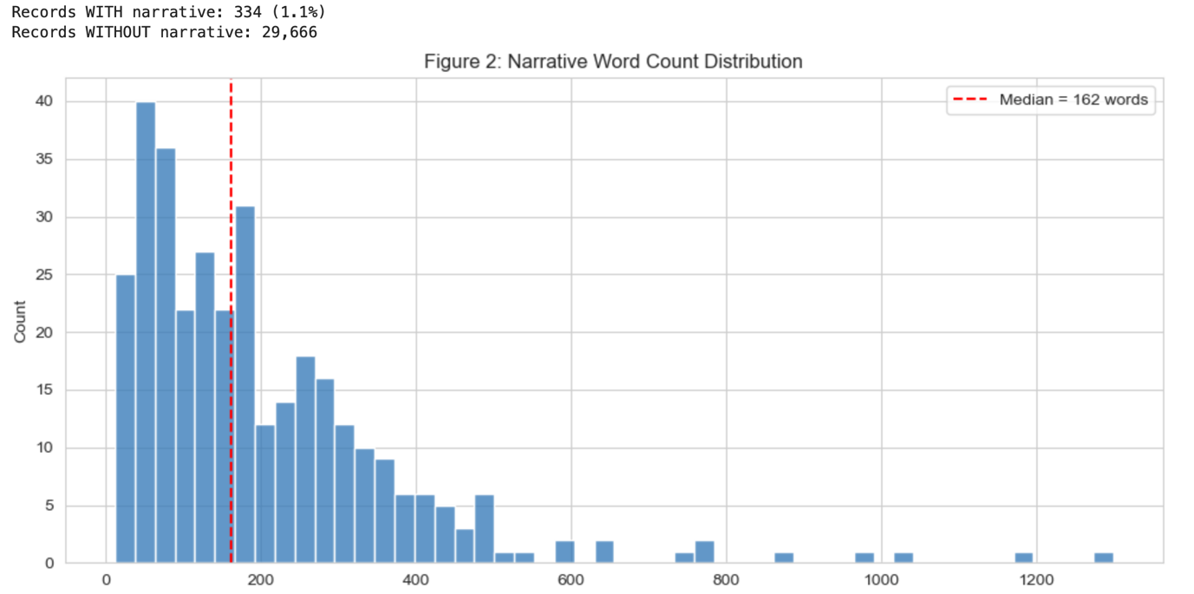
Distribution of records with and without complaint narratives.

4.5 Complaint Narrative Length
Narrative length analysis indicated that the available complaints generally contained sufficient detail for text mining and topic modelling.
After cleaning and preprocessing, 333 complaint narratives remained available for modelling.

4.6 Company Response Analysis
The company response variable was retained for contextual understanding of complaint handling practices but was not used as a predictive feature in the final sentiment model.

5. Data Cleaning and Preprocessing
The complaint narratives were cleaned before analysis.
The following preprocessing steps were applied:
- Converted text to lowercase.
- Removed URLs.
- Removed HTML tags.
- Removed CFPB redaction placeholders.
- Removed punctuation.
- Removed stopwords.
- Retained important negation words.
- Applied lemmatisation.
Following preprocessing:
Records Available for Analysis: 333
These steps reduced noise and improved model performance.
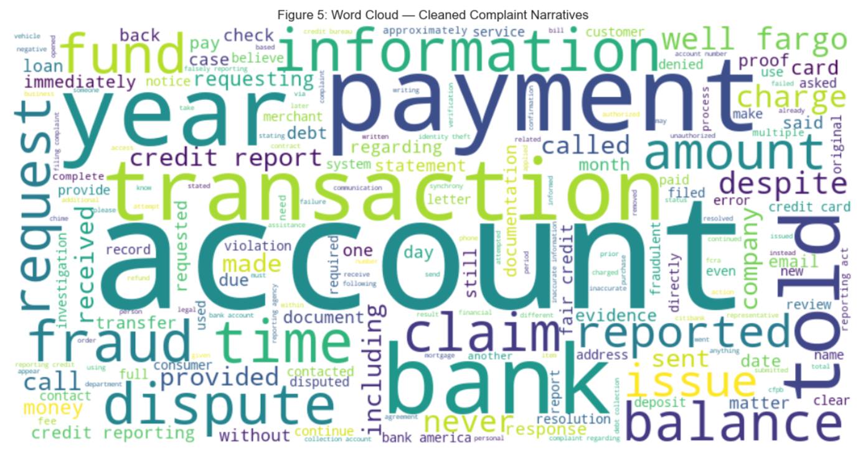
Word cloud of cleaned complaint narratives.

6. Sentiment Analysis

6.1 Sentiment Labelling
The CFPB dataset does not contain a sentiment label.
A keyword-based sentiment classification approach was therefore implemented to generate sentiment categories.

6.2 Sentiment Distribution
The sentiment distribution was as follows:
Sentiment | Count | Percentage
Negative | 191 | 57.4%
Neutral | 101 | 30.3%
Positive | 41 | 12.3%
The majority of complaints were classified as negative.
This suggests that customers primarily submit complaints when they experience service failures, billing disputes, account issues, or other negative interactions.
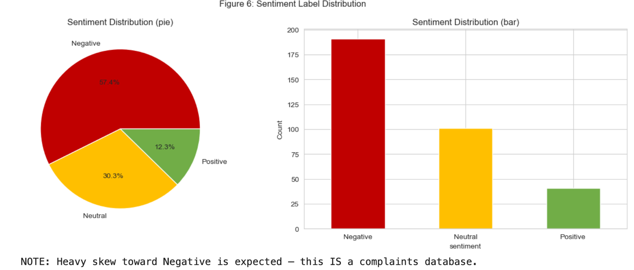
Sentiment Distribution Chart

7. Topic Modelling

7.1 LDA Topic Modelling
Latent Dirichlet Allocation (LDA) was applied to identify common themes within complaint narratives.
Six topics were generated from the complaint text. Topic modelling allows researchers to automatically discover latent semantic structures within large collections of text documents (Aggarwal and Zhai, 2012).
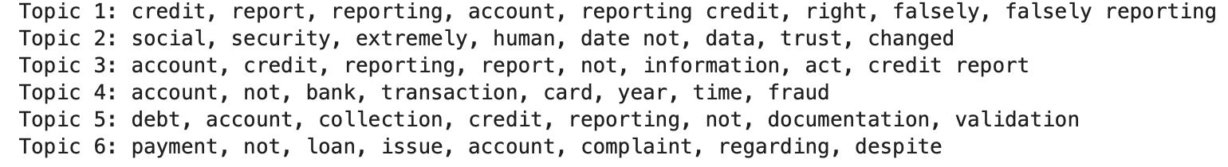

7.2 Topic Results
Topic | Main Keywords | Interpretation
Topic 1 | credit, report, reporting, account | Credit reporting disputes
Topic 2 | social, security, data, trust | Identity verification and personal information
Topic 3 | account, credit, reporting, information | Account reporting issues
Topic 4 | bank, transaction, card, fraud | Banking and fraud concerns
Topic 5 | debt, collection, validation | Debt collection complaints
Topic 6 | payment, loan, issue, complaint | Loan servicing and payment issues

7.3 Business Interpretation
The topic analysis identified several recurring complaint categories:
- Credit reporting errors
- Debt collection disputes
- Fraud and transaction issues
- Account management problems
- Loan servicing concerns
- Identity and information verification challenges
These represent the primary sources of customer dissatisfaction.

8. Feature Engineering
TF-IDF (Term Frequency-Inverse Document Frequency) was used to transform text into numerical features.
The resulting document-term matrix contained:
333 documents × 1,392 features
TF-IDF was selected because it reduces the impact of common words while highlighting informative terms useful for classification, making it one of the most widely used feature extraction techniques in text mining applications (Manning, Raghavan and Schütze, 2008).

9. Model Training

9.1 Data Split
The data was split into:
- 75% Training Data
- 25% Testing Data
Stratified sampling was used to preserve sentiment distributions.

9.2 Models Trained
Two machine learning pipelines were developed:

Model 1
TF-IDF + Logistic Regression

Model 2
TF-IDF + Multinomial Naive Bayes

10. Model Evaluation
The following metrics were used:
- Accuracy
- Precision
- Recall
- Weighted F1 Score
- Cross Validation

Weighted F1 Score was prioritised because the sentiment classes were imbalanced. Precision, recall and F1-score are widely recommended evaluation metrics for classification problems involving unequal class distributions (Sokolova and Lapalme, 2009).

10.1 Logistic Regression Results
Metric | Score
Accuracy | 66.7%
Precision | 68.1%
Recall | 66.7%
Weighted F1 | 64.5%

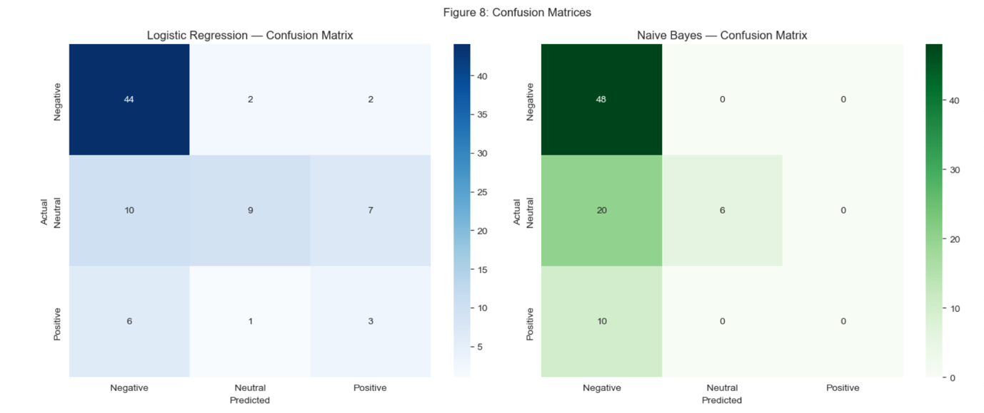
10.
Logistic Regression confusion matrix.

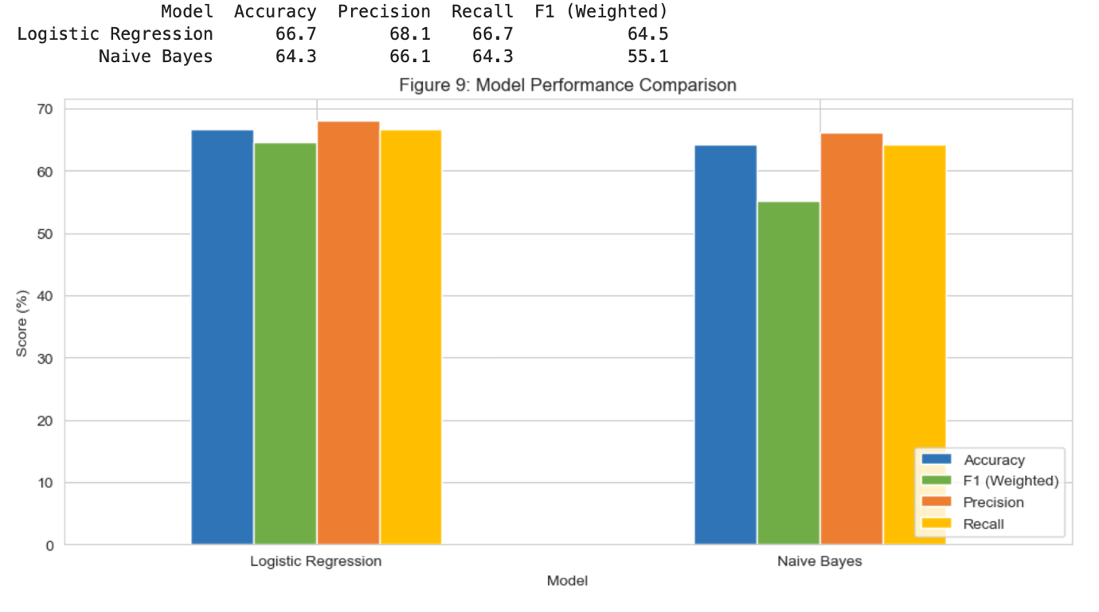
2 Naive Bayes Results
Metric | Score
Accuracy | 64.3%
Precision | 66.1%
Recall | 64.3%
Weighted F1 | 55.1%

10.3 Cross Validation
Model | Mean F1 Score
Logistic Regression | 62.8%
Naive Bayes | 52.4%
Cross-validation results demonstrate that Logistic Regression consistently outperformed Naive Bayes and generalised more effectively across folds.

11. Model Improvement
Several alternative parameter settings were tested during model evaluation.
However, the original Logistic Regression model remained the strongest performer.
Final selected model:
Metric | Score
Accuracy | 66.7%
Precision | 68.1%
Recall | 66.7%
Weighted F1 | 64.5%

12. Findings and Recommendations

Key Findings
- Negative sentiment accounted for 57.4% of all analysed complaints.
- Credit reporting disputes emerged as the most common complaint category.
- Debt collection and loan servicing issues were major sources of dissatisfaction.
- Fraud and account management concerns were recurring themes.
- Logistic Regression achieved the strongest classification performance.
- Topic modelling successfully identified actionable complaint categories.

Recommendations
- Prioritise improvements in credit reporting processes.
- Strengthen debt collection communication and dispute resolution procedures.
- Improve fraud prevention and transaction monitoring systems.
- Monitor customer sentiment continuously using automated text analytics tools.
- Use topic modelling regularly to identify emerging complaint trends before they become widespread.

Conclusion
This study successfully applied text analytics and machine learning techniques to analyse customer complaints from the CFPB Consumer Complaint Database.
The analysis revealed that negative sentiment dominates customer experiences, with credit reporting, debt collection, fraud, and loan servicing representing the primary complaint areas. Topic modelling provided valuable insights into the nature of customer concerns, while sentiment classification quantified overall customer perception.
Among the evaluated models, Logistic Regression achieved the highest performance with an accuracy of 66.7% and a weighted F1 score of 64.5%, making it the preferred model for future sentiment monitoring applications.
The findings support previous research demonstrating that machine learning and Natural Language Processing techniques can successfully transform unstructured customer feedback into actionable business intelligence (Liu, 2012; Jurafsky and Martin, 2023).
Overall, the results demonstrate how organisations can use customer complaint data to better understand customer experiences, identify recurring issues, and guide operational improvements aimed at increasing customer satisfaction.

References
Aggarwal, C.C. and Zhai, C. (2012) Mining Text Data. Boston: Springer.
Bird, S., Klein, E. and Loper, E. (2009) Natural Language Processing with Python. Sebastopol, CA: O’Reilly Media.
Blei, D.M., Ng, A.Y. and Jordan, M.I. (2003) ‘Latent Dirichlet Allocation’, Journal of Machine Learning Research, 3, pp. 993–1022.
Jurafsky, D. and Martin, J.H. (2023) Speech and Language Processing. 3rd ed.
Liu, B. (2012) Sentiment Analysis and Opinion Mining. San Rafael, CA: Morgan & Claypool.
Manning, C.D., Raghavan, P. and Schütze, H. (2008) Introduction to Information Retrieval. Cambridge: Cambridge University Press.
Provost, F. and Fawcett, T. (2013) Data Science for Business. Sebastopol, CA: O’Reilly Media.
Sokolova, M. and Lapalme, G. (2009) ‘A systematic analysis of performance measures for classification tasks’, Information Processing & Management, 45(4), pp. 427–437.
Tan, P.N., Steinbach, M. and Kumar, V. (2019) Introduction to Data Mining. 2nd ed. Harlow: Pearson.
Witten, I.H., Frank, E., Hall, M.A. and Pal, C.J. (2017) Data Mining: Practical Machine Learning Tools and Techniques. 4th ed.

